The Brightview Senior Living Facility consists of qty (4) DOAS systems. Each system has a heat wheel with supply & exhaust fans. Our focus for our analysis was DOAS-1, which serves the 1st floor Wing A area. There have been multiple testing agencies on site to evaluate the system each time returning data with conflicting information. The purpose of this analysis was to provide data that could have more conclusive results and a possible understanding of why different results were measured by different testing firms.
Unit Condition:
Per DJW DOAS filters have been replaced and Heat Wheel cleaned and serviced by facility staff prior to our testing. New filters were found inside the unit at time of testing. All doors have had additional foam added to seal gaps and to prevent leakage. No air supply/exhaust leakage could be felt around any access doors indicating the unit is well sealed. The only spot we’re there could be some short cycling is a bracket piece on the inside of the unit that is located in the coil/filter compartment. There was about a 1/8” gap (picture below) which most likely is negligible leakage. 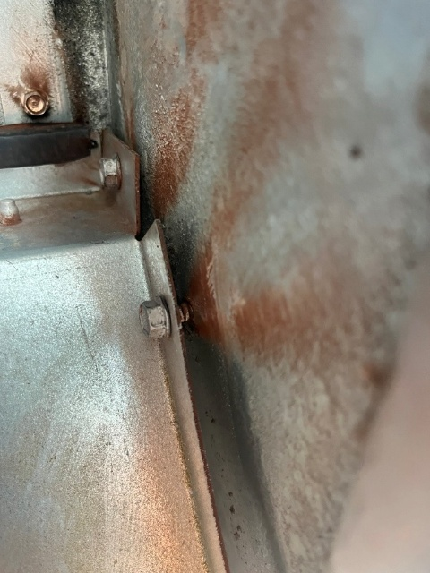
Exhaust Side:
Our initial intent was to try to perform a Duct Traverse of the main trunkline that drops down from the unit or at least the qty (2) branchlines that comes off the trunkline in the corridors and feeds each of the residence rooms. There was absolutely no access to any of these areas even when getting above the ceiling in other areas of the space & trying to work our way towards the trunkline. The only point for a traverse that allowed multiple grills (GRD’s) ducted prior to the traverse location was through access of a supply diffuser in the hallway that had exhaust GRD’s labeled 1-5 thru 1-11 (7 devices labeled on enclosed GRD layout). We were also able to perform duct traverses on several ducts serving individual exhaust grills.
The reason to perform additional duct traverses is to develop a correction factor (K Factor) to be used as a multiplier to the flow-hood value. All modern flow-hoods are designed with back pressure analysis that will calculate a corrected airflow (k factor) for every reading. However, it is only accurate typically with settle pressure and velocity patterns changes at the supply or exhaust grills. When you have erratic readings (inconsistency) or possibility of velocity profile at the orifice of the velocity grid located at the bottom of the utilized flow hood it will have impact on the recorded CFM value that the built in back pressure factor does not work. This will cause the inconsistency in readings that the team has experienced from different testing firms. It is NEBB guidelines and Flow-Hood Manufacturers recommendations to develop your own K factor when experiencing these issues in the field. For example, in extreme circumstances if you have uneven velocity across your flow-hood grid that is 5 times higher on one side versus the other side you will have an error of 20x. See pictures below. We pulled off several of the grills to inspect the duct configuration at the grills. The arrangement would create uneven exhaust or discharge at the grill. Larger plenum boxes had to be fabricated to allow for the fire dampers to be inserted inside the box just above the rated ceiling. Then the duct was cut in at the top of the plenum box either on the left, right, or center of box. This configuration would cause higher pressures on one side of the grill & lower on the other side with the compact arrangement. Our traverses taken did develop different K factors. So, we utilized an Average K factor of 1.27 for all flow-hood readings. Per flow-hood manufacturer recommendations we use a low-flow hood for any GRD measured at 150 CFM or less and a normal flow-hood for any devices of 150 CFM or more for better accuracy.
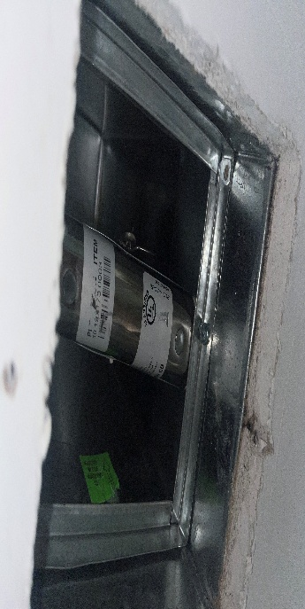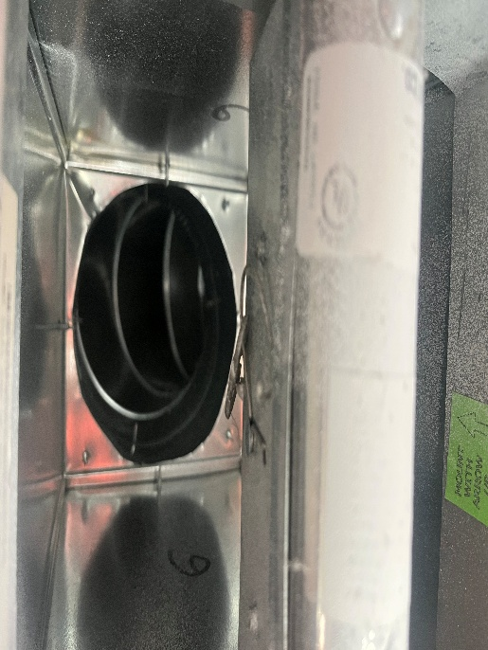

We also inspected the duct system above the hard ceiling as much as access would allow from traverse location to the exhaust grilles and found no sources of potential leakage. When we removed several of the exhaust grilles it was evident in each case that the fire rated sheetrock ceiling was sandwiched tight between the grill and the plenum box.
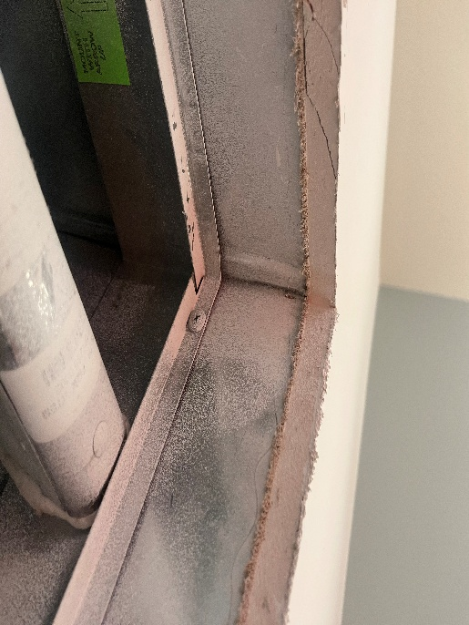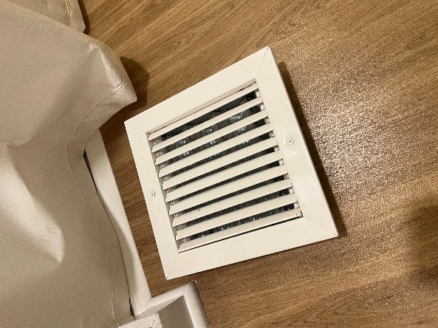

We pulled the insulation off the duct system where it tied to the top of the plenum boxes & found the duct was installed tight to the plenum box. Visually there was no evidence of duct construction that would allow for any significant leakage for a low pressure duct system.

Since we could not get a total duct traverse at the main trunkline to have additional validation of our developed K factor we wanted to evaluate fan performance at the unit. On the exhaust side of the unit the exhaust airflow can be compared to a manufacturer curve using RPM and Brake Horsepower (BHP). For the exhaust side of the system the design criteria are 1969 RPM at 1.07 BHP will equate to 2330 CFM. Actual measurements were 1989 RPM at 1.05 BHP which plots on a Manufacture performance curve of approximately 2400 CFM. Our final airflow measured at the exhaust grills utilizing a 1.27 K factor was 2307 CFM which lines up with fan/motor performance criteria. The discharge static pressure was lower than design.
Supply Side:
On the supply side of the system, it was not possible to obtain a traverse of any part of the trunkline or supply duct distribution system due to the location of the duct above hard ceiling in the hallway and clearance needed to insert the pitot tube. We attempted to take accurate flow-hood readings at all the supply GRD’s. There was no consistency in the readings. The phenomenon explained above for the exhaust side is more detrimental when taking supply readings. The hood readings on the supply side we deem as inaccurate with no way to triangulate other testing results to draw accurate conclusion. Since there is no access to any of the supply ductwork within the space it may be possible to retrofit the OA intake to get total supply airflow readings to help determine the proper airflow readings at the supply grills. The balancing dampers that are directly behind the face of the supply grill may have to all be opened 100% to get more consistent reading.

